# **LAB 1: Data Structures in Python**

## **Zeenia Asr - 382732**

**Task 1:**

rivers = [

{"name": "Nile", "length": 4157},

{"name": "Yangtze", "length": 3434},

{"name": "Murray-Darling", "length": 2310},

{"name": "Volga", "length": 2290},

{"name": "Mississippi", "length": 2540},

{"name": "Amazon", "length": 3915}

]

for i in range(len(rivers)):

print(rivers[i]["name"])

total=0

for j in range(len(rivers)):

total+=rivers[j]["length"]

print(total)

for name in range(len(rivers)):

if (rivers[name]["name"][0])=='M':

print(rivers[name]["name"])

for i in range(len(rivers)):

print(rivers[i]["name"])

print("Length in kilometres of", rivers[i]["name"], rivers[i]["length"]*1.6)

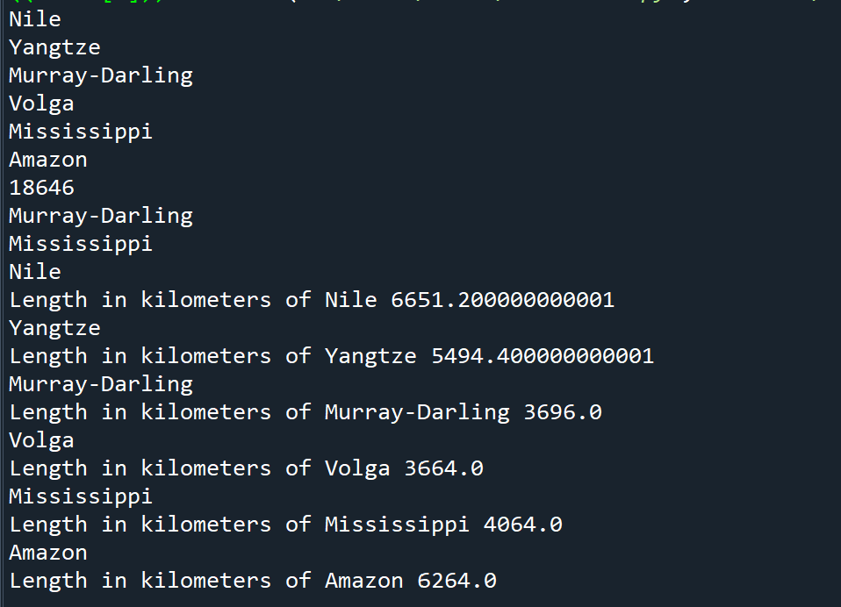

**Task 2:**

def overlap(x,y):

return[i for i in x if i in y]

print(overlap([1.0,2.0,4.5], [2.0,4.5,5.0]))

def joint(x,y):

z = [j for j in x]

z += [j for j in y if j not in x]

return z

print(joint([1.0,2.0,4.5], [2.0,4.5,5.0]))

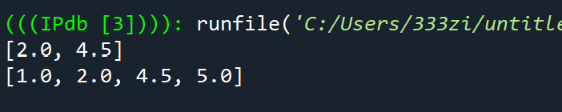

**Task 3:**

def get_names(spicy_foods):

f1=[]

for i in spicy_foods:

f1=f1+ [i['name']]

return f1

def get_spiciest_foods(spicy_foods):

f2=[]

for i in spicy_foods:

if i['heat_level']>=5:

f2=f2+[i]

return f2

def print_spicy_foods(spicy_foods):

for i in spicy_foods:

a=i['name']

b=i['cuisine']

c=i['heat_level']

print(a,'(',b,')','Heat Level:',('🌶')*c)

def get_spicy_food_by_cuisine(spicy_foods,cuisine):

for i in spicy_foods:

f4=i['cuisine']

if f4==cuisine:

print(i)

def print_spiciest_foods(spicy_foods):

for i in spicy_foods:

if i['heat_level']>5:

a=i['name']

b=i['cuisine']

c=i['heat_level']

print(a,'(',b,')','Heat Level:',('🌶')*c)

def get_average_heat_level(spicy_foods):

f5=0

for i in spicy_foods:

f5=f5+i['heat_level']

print('Average heat level of all spicy foods is',f5/len(spicy_foods))

def create_spicy_food(spicy_foods, spicy_food):

print(spicy_foods+[spicy_food])

spicy_food={'name': 'Griot',

'cuisine': 'Haitian',

'heat_level': 10,}

cuisine='Thai'

def main():

print(get_names(spicy_foods))

print(get_spiciest_foods(spicy_foods))

print(print_spicy_foods(spicy_foods))

print(get_spicy_food_by_cuisine(spicy_foods, cuisine))

print(print_spiciest_foods(spicy_foods))

print(get_average_heat_level(spicy_foods))

print(create_spicy_food(spicy_foods, spicy_food))

if __name__=="__main__":

main()

